JAHANGIRABAD

Bank Management


[As a part of the Informatics Practices Course (065)]

Nishant Gupta

Mr. Faiq Masood
PGT (Computer Science)
CERTIFICATE
This is to certify that the Project / Dissertation entitled Bank Management is a bonafide work done by NISHANT GUPTA of class XII Session 2018-19 in partial fulfillment of CBSE’s AISSCE Examination 2019 and has been carried out under my direct supervision and guidance. This report or a similar report on the topic has not been submitted for any other examination and does not form a part of any other course undergone by the candidate.

Signature of Student Signature of Teacher

Name: Soham Goyal Name: Mr. Faiq Masood
Cbse Roll No: Designation: PGT(Comp.Sc.)

ACKNOWLEDGEMENT
I
undertook this Project work, as the part of my XII-Informatics Practices course. I had tried to apply my best of knowledge and experience, gained during the study and class work experience. However, developing software system is generally a quite complex and time-consuming process. It requires a systematic study, insight vision and professional approach during the design and development. Moreover, the developer always feels the need, the help and good wishes of the people near you, who have considerable experience and idea.
I would like to extend my sincere thanks and gratitude to my teacher Mr. Faiq Masood. I am very much thankful to our Principal Mr. N.K. Tyagi for giving valuable time and moral support to develop this software.
I would like to take the opportunity to extend my sincere thanks and gratitude to my parents for being a source of inspiration and providing time and freedom to develop this software project.
I also feel indebted to my friends for the valuable suggestions during the project work.

NISHANT GUPTA

Class XII

CONTENTS
1. Introduction 5
2. Objective & Scope of the Project 6
3. Theoretical Background 7
4. System Implementation 10
4.1 The Hardware used: 10
4.2 The Softwares used: 10
5. System Design & Development 11
5.1 Database Design: 11
5.2 I/O Forms Design & Event Coding: 12
6. User Manual 20
6.1 How to install: 20
7. References 21

INTRODUCTION
This software project is developed to automate the functionalities of Banks.The purpose of the software project is to develop a program which provides a friendly interface for the Higher Authority to manage the accounts of students and to know their Information. When this program made to work by most Banks then it can be prove to be an ultimate way of usage for them.
A MIS mainly consists of a computerized database, a collection of inter-related tables for a particular subject or purpose, capable to produce different reports relevant to the user. An application program is tied with the database for easy access and interface to the database. Using Application program or front-end, we can store, retrieve and manage all information in proper way.
This software, being simple in design and working, does not require much of training to officers but controlled fully by a tyro officer, and can be used as a powerful tool for the Bank Management .
During coding and design of the software Project, python a powerful front-end tool is used for getting Graphical User Interface (GUI) based integrated platform and coding simplicity. As a back-end a powerful, open source RDBMS, My SQL is used as per requirement of the CBSE curriculum of Informatics Practices Course.

Objective & Scope of the Project
T
he objective of the software project is to develop the functions of Banks. This software project is also aimed to enhance the current record keeping system, which will help managers to retrieve the up-to-date information at right time in right shape.
The proposed software system is expected to do the following functionality-
- To provide a user friendly.
- The proposed system should maintain all the records and transactions, and should generate the required reports and information when required.
- To provide graphical and user-friendly interface to interact with a centralized database based on client-server architecture.
- To identify the critical operation procedure and possibilities of simplification using modern IT tools and practices.
In its current scope, the software enables Officer to retrieve and update the information from centralized database designed with MySQL . This software does not require much training time of the users due to limited functionality and simplicity.
Despite of the best effort of the developer, the following limitations and functional boundaries are visible, which limits the scope of this application software.
- This software can store records and produce reports in pre-designed format in soft copy. There is no facility yet to produce customized reports. Only specified reports are covered.
- There is no provision to calculate fine or penalty etc. for defaulter members; however it can be developed easily with the help of adding modules.
- Some application areas like Updation along with Intrest of Money, Taking of Loan etc. are not implemented in the project. This project is made by keeping in mind that it is to be used only by Officers, which can facilitate ease control.
So far as future scope of the project is concerned, firstly it is open to any modular expansion i.e. other modules or functions can be designed and embedded to handle the Officer need in future. Any part of the software and reports can be modified independently without much effort.

Theoretical Background

What is Database?

Introduction and Concepts:
A database is a collection of information related to a particular subject or purpose, such as tracking customer orders or maintaining a product collection. Using any RDBMS application software like MS SQL Server, MySQL, Oracle, Sybase etc, you can manage all your information from a single database file. Within the file, divide your data into separate storage containers called tables. You may and retrieve the data using queries.
A table is a collection of data about a specific topic, such as products or suppliers. Using a separate table for each topic means you can store that data only once, which makes your database more efficient and reduces data-entry errors. Table organises data into columns (called fields) and rows (called records).
A Primary key is one or more fields whose value or values uniquely identify each record in a table. In a relationship, a primary key is used to refer to specific record in one table from another table. A primary key is called foreign key when it is referred to from another table.

To find and retrieve just the data that meets conditions you specify, including data from multiple tables, create a query. A query can also update or delete multiple records at the same time, and perform built-in or custom calculations on your data.
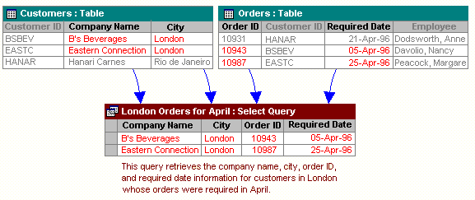

Role of RDBMS Application Program:
A computer database works as a electronic filing system, which has a large number of ways of cross-referencing, and this allows the user many different ways in which to re-organize and retrieve data. A database can handle business inventory, accounting and filing and use the information in its files to prepare summaries, estimates and other reports. The management of data in a database system is done by means of a general-purpose software package called a Database Management System (DBMS). Some commercially available DBMS are MS SQL Server, MS ACCESS, INGRES, ORACLE, and Sybase. A database management system, therefore, is a combination of hardware and software that can be used to set up and monitor a database, and can manage the updating and retrieval of database that has been stored in it. Most of the database management systems have the following capabilities:
- Creating of a table, addition, deletion, modification of records.
- Retrieving data collectively or selectively.
- The data stored can be sorted or indexed at the user's discretion and direction.
- Various reports can be produced from the system. These may be either standardized report or that may be specifically generated according to specific user definition.
- Mathematical functions can be performed and the data stored in the database can be manipulated with these functions to perform the desired calculations.
- To maintain data integrity and database use.
The DBMS interprets and processes users' requests to retrieve information from a database. In most cases, a query request will have to penetrate several layers of software in the DBMS and operating system before the physical database can be accessed. The DBMS responds to a query by invoking the appropriate subprograms, each of which performs its special function to interpret the query, or to locate the desired data in the database and present it in the desired order.

What is My SQL ? 
The management of data in a database system is done by means of a general-purpose software package called a Database Management System (DBMS). Some commercially available RDBMS are MS SQL Server, MS ACCESS, INGRES, ORACLE, and Sybase.
MySQL, the most popular Open Source SQL database management system, is developed, distributed, and supported by Oracle Corporation. MySQL is named after co-founder Monty Widenius's daughter, My. The name of the MySQL Dolphin (our logo) is “Sakila,”.
- MySQL is a database management system.
A database is a structured collection of data. It may be anything from a simple shopping list to a picture gallery or the vast amounts of information in a corporate network. To add, access, and process data stored in a computer database, you need a database management system such as MySQL Server. Since computers are very good at handling large amounts of data, database management systems play a central role in computing, as standalone utilities, or as parts of other applications.
- MySQL is based on SQL.
A relational database stores data in separate tables rather than putting all the data in one big storeroom. This adds speed and flexibility. The SQL part of “MySQL” stands for “Structured Query Language.” SQL is the most common standardized language used to access databases and is defined by the ANSI/ISO SQL Standard. The SQL standard has been evolving since 1986 and several versions exist. In this manual, “SQL-92” refers to the standard released in 1992, “SQL:1999” refers to the standard released in 1999, and “SQL:2003” refers to the current version of the standard.
- MySQL software is Open Source.
Open Source means that it is possible for anyone to use and modify the software. Anybody can download the MySQL software from the Internet and use it without paying anything. If you wish, you may study the source code and change it to suit your needs. The MySQL software uses the GPL (GNU General Public License),
- The MySQL Database Server is very fast, reliable, and easy to use.
If that is what you are looking for, you should give it a try. MySQL Server also has a practical set of features developed in close cooperation with our users. You can find a performance comparison of MySQL Server with other database managers on our benchmark page. MySQL Server was originally developed to handle large databases much faster than existing solutions and has been successfully used in highly demanding production environments for several years. Although under constant development, MySQL Server today offers a rich and useful set of functions. Its connectivity, speed, and security make MySQL Server highly suited for accessing databases on the Internet.
- MySQL Server works in client/server or embedded systems.
The MySQL Database Software is a client/server system that consists of a multi-threaded SQL server that supports different backends, several different client programs and libraries, administrative tools, and a wide range of application programming interfaces (APIs).

The Main Features of MySQL
- Written in C and C++.
- Works on many different platforms.
- Uses multi-layered server design with independent modules.
- Provides transactional and nontransactional storage engines.
- Designed to make it relatively easy to add other storage engines. This is useful if you want to provide an SQL interface for an in-house database.
- Uses a very fast thread-based memory allocation system.
- Executes very fast joins using an optimized nested-loop join.
- Implements SQL functions using a highly optimized class library that should be as fast as possible. Usually there is no memory allocation at all after query initialization.
- Provides the server as a separate program for use in a client/server networked environment, and as a library that can be embedded (linked) into standalone applications. Such applications can be used in isolation or in environments where no network is available.
- Password security by encryption of all password traffic when you connect to a server.
- Support for large databases. We use MySQL Server with databases that contain 50 million records. We also know of users who use MySQL Server with 200,000 tables and about 5,000,000,000 rows.
- MySQL client programs can be written in many languages. A client library written in C is available for clients written in C or C++, or for any language that provides C bindings.
- APIs for C, C++, Eiffel, Java, Perl, PHP, Python, Ruby, and Tcl are available, enabling MySQL clients to be written in many languages.
- The Connector/ODBC (MyODBC) interface provides MySQL support for client programs that use ODBC (Open Database Connectivity) connections.
- The Connector/J interface provides MySQL support for Java client programs that use JDBC connections. Clients can be run on Windows or Unix. Connector/J source is available.

System Implementation

The Hardware used:

While developing the system, the used hardware are:
PC with Pentium Dual Core processor having 2.00 GB RAM, SVGA and other required devices.

The Softwares used:
- Microsoft Windows® 7 as Operating System.
- Python 3.7 as Front-end Development environment.
- MySQL as Back-end Sever with Database for Testing.
- MS-Word 2007 for documentation.

System Design & Development

Database Design:
An important aspect of system design is the design of data storage structure. To begin with a logical model of data structure is developed first. A database is a container object which contains tables, queries, reports and data validation policies enforcement rules or contraints etc. A logical data often represented as a records are kept in different tables after reducing anomalies and redundancies. The goodness of data base design lies in the table structure and its relationship.
This software project maintains a database named Banks which contains the following tables.

Tables:-
In my awesome and amizing software of banks I have created to tables to make the software user friendly and to make it different from others.Tables are shown below.

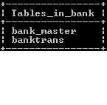

1.Bank_master:-

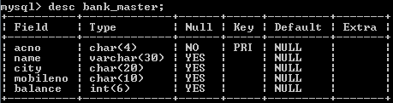

2.Banktrans:-

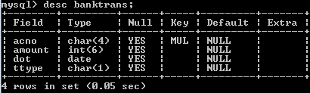

Project View

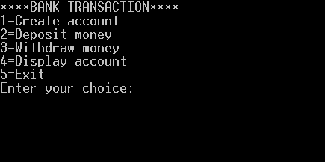

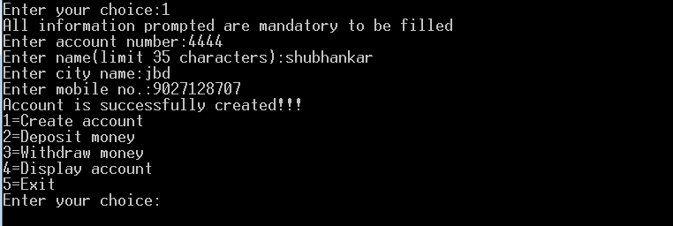





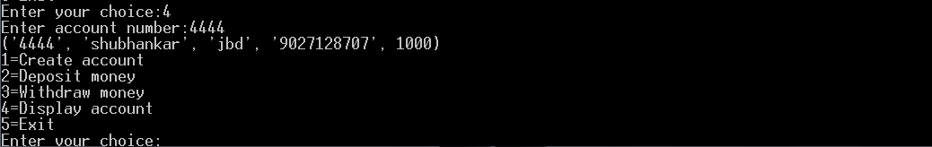

Pyton Coding:-
#SOURCE CODE FOR BANKING TRANSACTIONS
print("****BANK TRANSACTION****")
#creating database
import mysql.connector
mydb=mysql.connector.connect(host="localhost",user="root",passwd="1234")
mycursor=mydb.cursor()
mycursor.execute("create database if not exists bank")
mycursor.execute("use bank")
#creating required tables
mycursor.execute("create table if not exists bank_master(acno char(4) primary key,name varchar(30),city char(20),mobileno char(10),balance int(6))")
mycursor.execute("create table if not exists banktrans(acno char (4),amount int(6),dot date ,ttype char(1),foreign key (acno) references bank_master(acno))")
mydb.commit()
while(True):

print("1=Create account")
print("2=Deposit money")
print("3=Withdraw money")
print("4=Display account")
print("5=Exit")
ch=int(input("Enter your choice:"))

#PROCEDURE FOR CREATING A NEW ACCOUNT OF THE APPLICANT
if(ch==1):
print("All information prompted are mandatory to be filled")
acno=str(input("Enter account number:"))
name=input("Enter name(limit 35 characters):")
city=str(input("Enter city name:"))
mn=str(input("Enter mobile no.:"))
balance=0
mycursor.execute("insert into bank_master values('"+acno+"','"+name+"','"+city+"','"+mn+"','"+str(balance)+"')")
mydb.commit()
print("Account is successfully created!!!")

#PROCEDURE FOR UPDATIONG DETAILS AFTER THE DEPOSITION OF MONEY BY THE APPLICANT
elif(ch==2):
acno=str(input("Enter account number:"))
dp=int(input("Enter amount to be deposited:"))
dot=str(input("enter date of transaction:"))
ttype="d"
mycursor.execute("insert into banktrans values('"+acno+"','"+str(dp)+"','"+dot+"','"+ttype+"')")
mycursor.execute("update bank_master set balance=balance+'"+str(dp)+"' where acno='"+acno+"'")
mydb.commit()
print("money has been deposited successully!!!")
#PROCEDURE FOR UPDATING THE DETAILS OF ACCOUNT AFTER THE WITHDRAWL OF MONEY BY THE APPLICANT

elif(ch==3):
acno=str(input("Enter account number:"))
wd=int(input("Enter amount to be withdrawn:"))
dot=str(input("enter date of transaction:"))
ttype="w"
mycursor.execute("insert into banktrans values('"+acno+"','"+str(wd)+"','"+dot+"','"+ttype+"')")
mycursor.execute("update bank_master set balance=balance-'"+str(wd)+"' where acno='"+acno+"'")
mydb.commit()

#PROCEDURE FOR DISPLAYING THE ACCOUNT OF THE ACCOUNT HOLDER AFTER HE/SHE ENTERS HIS/HER ACCOUNT NUMBER
elif(ch==4):
acno=str(input("Enter account number:"))
mycursor.execute("select * from bank_master where acno='"+acno+"'")
for i in mycursor:
print(i)
else:
break
#ENDING OF THE SOURCE CODE

User Manual

How to installSoftware:

Hardware Requirement-
- Intel Pentium/Celeron or similar processor based PC at Client/Server end.
- 128 MB RAM and 4GB HDD space (for Database) is desirable.
- Standard I/O devices like Keyboard and Mouse etc.
- Printer is needed for hard-copy reports.
- Local Area Network(LAN) is required for Client-Server Installation

Software Requirement-
- Windows XP/2007 OS is desirable.
- Python must be installed and mysql connector must be installed.
- MySQL Ver 6.1 with Library Database must be present at machine.

References

In order to work on this project titled –Bank Managewment System, the following books and literature are refered by me during the various phases of development of the project.

(1) The Complete Reference python
-by Shildit
- MySQL, Black Book
-by Steven Holzner
(2) Understanding SQL
– Gruber
(3) http://www.mysql.org/

(4) Course Book for class XII

(5) Together with Informatics Practices
(6) Various Websites of Discussion Forum and software development activities.

Other than the above-mentioned books, the suggestions and supervision of my teacher and my class experience also helped me to develop this software project.

